**EAST WEST UINVERSITY**

**Department of Computer Science and Engineering**

**Post Lab**

**Semester:** Summer’17

**Course code:** CSE 251 (2)

**Course title:** Electronic Circuits

**Experiment No:** 02

**Experiment title:** Half-Wave Diode Rectifier Circuit

**Submitted to:**

Surajit Das Barman

Senior Lecturer

Department of CSE

East West University

**Submitted by:**

Kowser Mahmud Tanim

ID: 2015-2-60-062

Group No: 05

Group IDs: 2015-2-60-078, 2015-2-60-057, 2015-2-60-108

**Date of performance:** 23/05/2017

**Date of report submission:** 30/05/2017

**Experiment No:** 02

**Experiment title:** Half-Wave Diode Rectifier Circuit

**Objectives**

1. To study half-wave diode rectifier circuit.
2. To study the effect of a capacitor filter on the output of the rectifier circuit.

**Circuit Diagram**



**Figure:** Set up for a half-wave diode rectifier circuit

**Equipments and Components Used**

1. Signal Generator
2. Digital multimeter
3. Diode (1 pc)
4. Resistor 1KΩ (1 pc)
5. Capacitor 10F (1 pc)
6. Breadboard
7. Connecting wires
8. Pspice

**Question Answer**

1. The measured value of,

Vp = 960mV

=.96 V

In Exp1 the built in voltage is, .7V

There is a little difference between built in voltage of Exp1 and the measured voltage. Most probably that is .26V.

1. The measured t value is .110s.

The value we found from pre-lab is, t =.071s.

There is a very little amount of difference between pre-lab and measured value, that is .039s.

**3** . Peak-peak ripple voltage

Vr= Vp (ω∆t)^2 /2

= 5(2×3.1416×1000×.1×10-3)^ 2 /2

= 0.987V

Compare of measured, calculated and pre-lab voltage:

Calculated, Vr(V) =0.987V

Measured, Vr(V)= 0.36V

Pre- lab ,Vr(V) =0.5V

**Comments:** There is a little difference between calculated,

Measured value and pre lab values.

**4.** Here,

Vr= 0.36V

Vp= .96V

Vo= Vp- Vr/2

= .96-.36/2

= .3V

Calculated Vo(V) =3V

Measured Vo(V)= 3.019V

**5.** IL=Vo/R

= 3.9/ 0.9788

= 3.98 mA

IDavg=IL × (1+∏√(2Vp/Vr))

= 3.98× (1+3.1416√(2×5/0.36))

= 32.85mA

IDmax=IL× (1+2∏√(2VP/Vr)

= 3.98× (1+2×3.1416√(2×.96/0.36))

= 61.74mA

Current Measured value,

IDavg =32.85 mA

Pre-lab value,

IDavg =71.48 mA

Current Measured value,

IDmax =61.74mA

Pre-lab value

IDmax=138.22mA

**Comment:** The measured and pre lab values are almost double .

**6.** 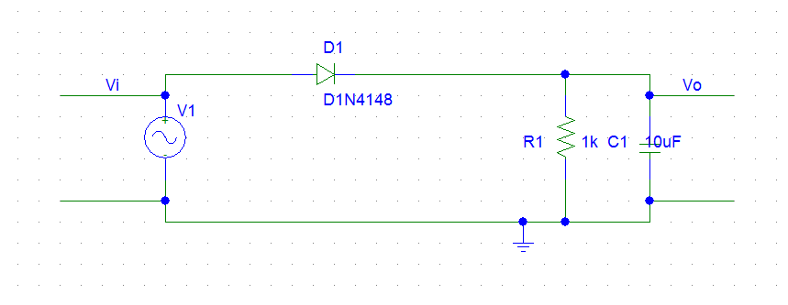

Figure: Set up for a half-wave diode rectifier circuit

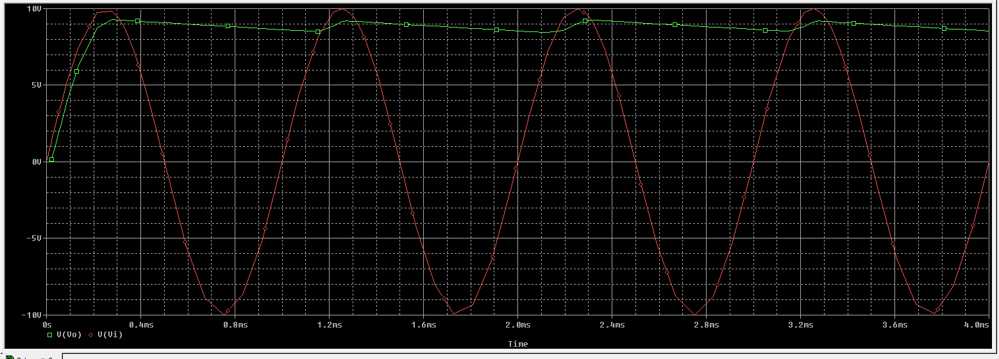

Figure: The sin-wave of half wave rectifier

**Conclusion**

In this experiment, I have learned the characteristics of a diode. I have used PSpice to simulate the circuit. I have learned to measure peak to peak voltage, ripple voltage & also simulate a function through Oscilloscope.

From the data I can calculate $I_{Davg}$ and $I_{D max}$. These values are lower than the pre lab values.